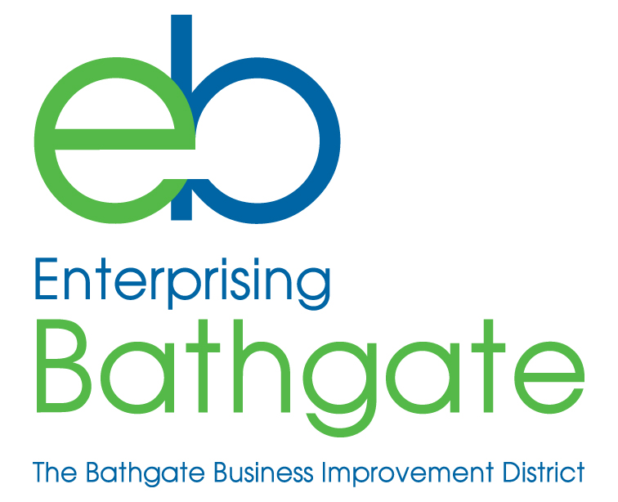

2019-20 PREMISES IMPROVEMENT SCHEME - APPLICATION FORM

NAME OF BUSINESS / ORGANISATION
CONTACT NAME
TEL.NO.
E-MAIL ADDRESS
ADDRESS OF RATEABLE PROPERTY
DESCRIPTION OF IMPROVEMENTS
COST OF IMPROVEMENTS
- encl. estimate(s) / invoice(s)
ARE YOU VAT REGISTERED?

- This scheme covers qualifying improvements carried out and invoiced between 1st April 2019 and 31st March 2020
- IT IS A CONDITION OF PAYMENT OF GRANT THAT THERE IS NO OVERDUE BID LEVY PAYABLE

Please provide your bank details to facilitate payment of grant:

Name of account
Sort code
Account number

Signed: ____________________________________

Print Name: ____________________________________

Date: ____________________________________

Please return completed form to: Sam Crawford,
Enterprising Bathgate Ltd,
Bathgate Business Centre,
Whitburn Road,
Bathgate, EH48 1HH

