PREMISES IMPROVEMENT SCHEME  APPLICATION FORM  This scheme covers qualifying improvements carried out and invoiced between 1 July 2022 – 30 June 2023 |  | 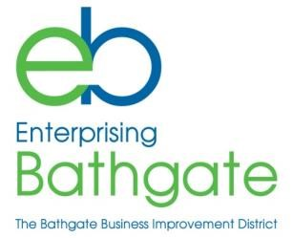
NAME OF BUSINESS / ORGANISATION
CONTACT NAME
TEL.NO.
E-MAIL ADDRESS
ADDRESS OF RATEABLE PROPERTY
DESCRIPTION OF IMPROVEMENTS
Any improvements to the actual property, internal or external, may qualify for a grant. Examples include:
- new signage
- replacing doors and windows
- painting frontages
- internal painting
- installing heating
- upgrading toilets or staff facilities
- electrical improvements
- replacing ceilings and lighting
- new flooring
COST OF IMPROVEMENTS
Please enclose estimate(s) / invoice(s)
ARE YOU VAT REGISTERED?
- I confirm that there is no outstanding BID Levy payable on the property
- I confirm that, where required, I have applied for all relevant building or planning consents or permissions, statutory or otherwise.

SIGNED: _________________________________________________
PRINT NAME:_____________________________________________
DATE:___________________________________________________

Please provide your bank details to facilitate payment of grant:
Name of Account |  |  | Please email completed form to: info@bathgatebid.net  Or to Enterprising Bathgate Ltd,  Bathgate Business Centre,  Whitburn Road, Bathgate, EH48 1HH
Sort Code
Account Number

